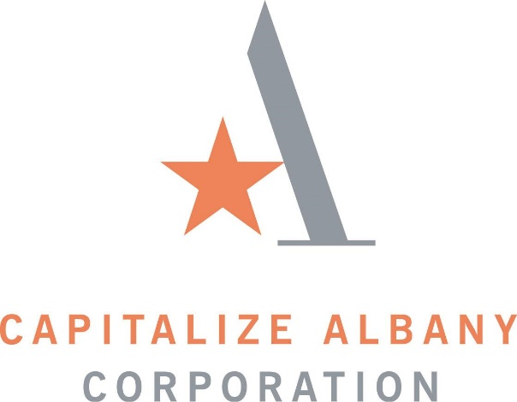

NOTICE

CORPORATE GOVERNANCE & NOMINATING COMMITTEE MEETING

A Corporate Governance & Nominating Committee Meeting of the Capitalize Albany Corporation will be held on Monday, April 22nd, at 10:00 a.m. at
21 Lodge Street, Albany NY 12207 - Conference Room.

