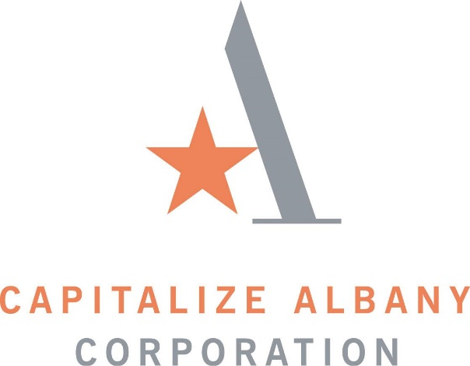

NOTICE

REGULAR BOARD MEETING

A Regular Meeting of the Capitalize Albany Corporation will be held on Tuesday, April 23rd, 2024 at 8:00 a.m. at 21 Lodge Street Albany, NY 12207 – Conference Room.

